**Cluster Creation**

**1.**

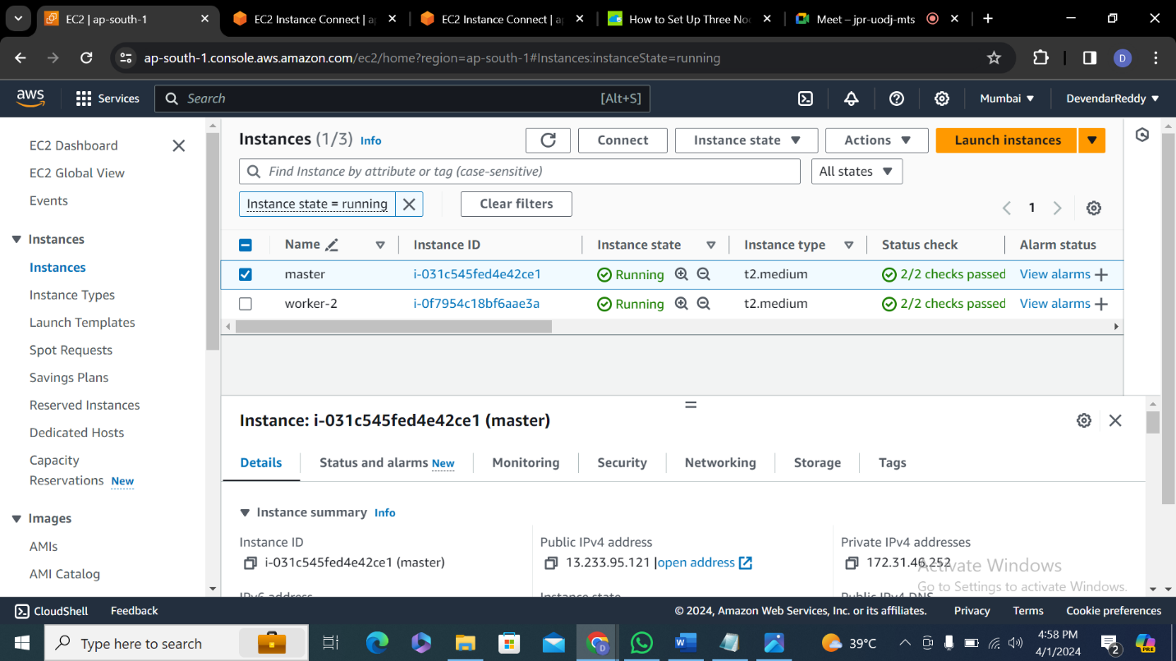

**2.**

1. tee /etc/modules-load.d/containerd.conf <<EOF

overlay

br_netfilter

EOF

2. modprobe overlay

3 . modprobe br_netfilter

4. tee /etc/sysctl.d/kubernetes.conf<<EOF

net.bridge.bridge-nf-call-ip6tables = 1

net.bridge.bridge-nf-call-iptables = 1

net.ipv4.ip_forward = 1

EOF

5. sysctl --system

6. curl -fsSL https://download.docker.com/linux/ubuntu/gpg | sudo gpg --dearmor -o /etc/apt/keyrings/docker.gpg

7. echo "deb [arch=$(dpkg --print-architecture) signed-by=/etc/apt/keyrings/docker.gpg] https://download.docker.com/linux/ubuntu \

$(lsb_release -cs) stable" | sudo tee /etc/apt/sources.list.d/docker.list > /dev/null

8. apt-get update && apt-get install -y containerd.io

9. mkdir -p /etc/containerd

10. containerd config default>/etc/containerd/config.toml

11. sed -e 's/SystemdCgroup = false/SystemdCgroup = true/g' -i /etc/containerd/config.toml

12. systemctl daemon-reload

13. systemctl restart containerd

14. systemctl enable containerd

15. systemctl status containerd

16. apt-get update && apt-get install -y apt-transport-https ca-certificates curl

17. curl -fsSL https://pkgs.k8s.io/core:/stable:/v1.27/deb/Release.key | sudo gpg --dearmor -o /etc/apt/keyrings/kubernetes-apt-keyring.gpg

18. echo 'deb [signed-by=/etc/apt/keyrings/kubernetes-apt-keyring.gpg] https://pkgs.k8s.io/core:/stable:/v1.27/deb/ /' | sudo tee /etc/apt/sources.list.d/kubernetes.list

19. apt-get update && apt-get install -y kubelet kubeadm kubectl

20. apt-mark hold kubelet kubeadm kubectl

21. systemctl enable kubelet

22. kubeadm init

23. export KUBECONFIG=/etc/kubernetes/admin.conf

24. echo 'export KUBECONFIG=/etc/kubernetes/admin.conf' >> .bashrc

25. kubectl get nodes

26. kubectl apply -f https://github.com/weaveworks/weave/releases/download/v2.8.1/weave-daemonset-k8s.yaml

27. kubectl get nodes1. <https://github.com/iam-veeramalla/aws-devops-zero-to-hero#readme>

**3.**

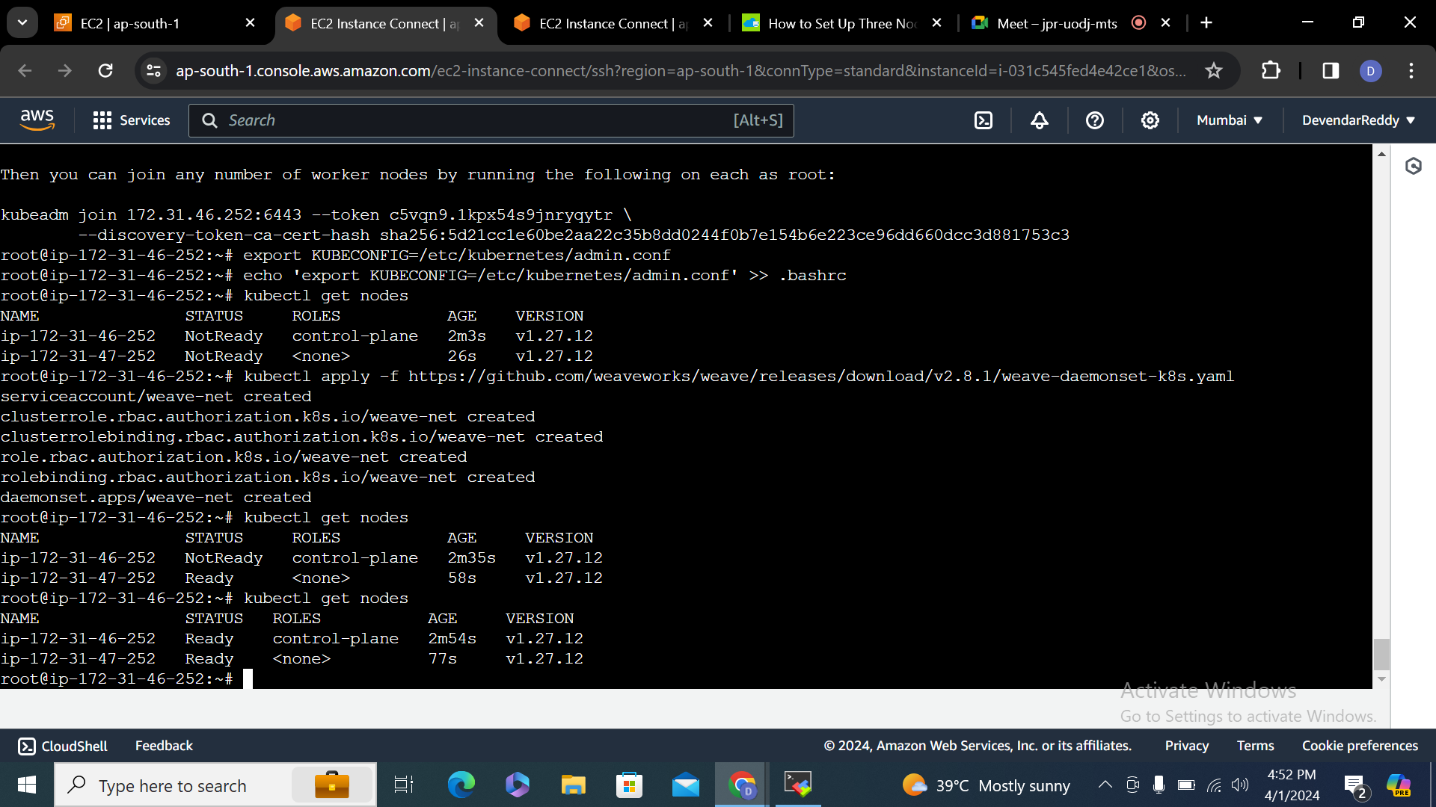

**4.**

